How to use Stellarium in your classroom

Using Stellarium
- Open Stellarium from the deskop.
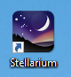
- Stellarium is launched in full screen mode. If needed, press F11 to take Stellarium out of full screen mode. Stellarium has two menus – one at the bottom and one on the lower left side. These are hidden until you move your mouse over them.

- You can use the arrow keys or the mouse to pan and tilt the view. You can use the Mouse wheel or the Page Up/Page Down buttons to zoom. Practice moving and zooming for a few minutes.

- Stellarium has different telescope view built in. These views are in the top right corner. Left click on the Sun and then select the Ocular view (highlighted in red below).
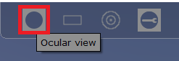
You should now see a telescopic view of the Sun. Press the Ocular view button again when you are finished.

- The bottom left will show the current viewing location. If it is not correct, move your mouse to the lower left until the left menu appears. Select the top button (Location). In the picture below, the location button (compass rose icon) is highlighted. You can also press F6 on your keyboard.
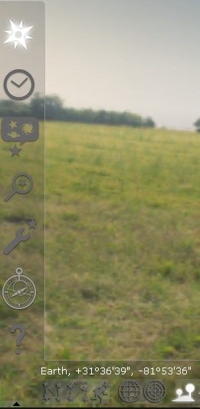

- Skip this step if your location is already correct.
Enter the latitude and longitude as seen in the picture below. Enter the Name/City. Check User current location as default and press Add to list. Check Enable daylight savings time. The red arrow on the earth map should be over your location now. If so, close the location window.

- In the lower left menu, select the Date/Time button (Clock button). You can also press F5 on your keyboard. Set the date to 2017 – 8 – 21 and the time to 12:10. Find the Sun – click on it – and then press the Space key on your keyboard. Your view will now stay centered on the Sun.
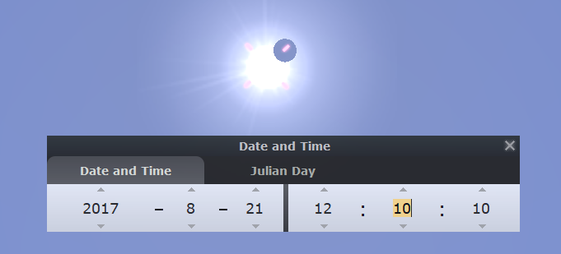

- You can now increment the time forward by minutes to see the Moon cross over the Sun. Once the Moon moves in front of the Sun, an Eclipse Factor percentage will appear in the top left.
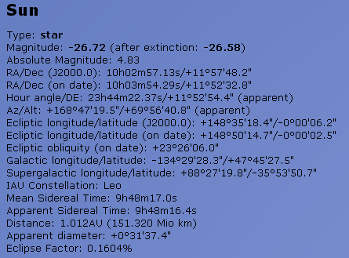

Things to teach with Stellarium
- Watch the eclipse in advance. Set the date/time to 2017-08-21 12:00. Select the Sun and press the space key to stay centered on our star. On the bottom menu, use the time controls to speed up time. Find the maximum eclipse percentage and pause time.
  - Note the planets visible at maximum eclipse.
  - Use the ocular view to view the Sun/Moon.
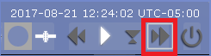

- There are four types of solar eclipses. Compare this eclipse to past and future eclipses by going to these dates and using the ocular view on the sun:
  - 1970 – 3 – 7 13:23:00 -Total eclipse
  - 2024 – 4 – 8 15:04:00 -Partial eclipse but with more of the sun uncovered
  - 1940 – 4 – 7 17:07:00 -Annular (ring of fire) eclipse

- Why don’t we have a solar eclipse every month? Show how the new Moon is rarely in front of the Sun from our perspective by going to these dates:
  - 2017 – 07 – 23
  - 2017 – 09 – 19

Resources
- Stellarium Handbook
- Stellarium User guide (Chapters 10 and 11)

